* Rolling Mean (120 days): The mean of the returns is very close to zero, indicating that there is no significant upward or downward trend in the average returns over the 120-day period.
* Rolling Standard Deviation (120 days): The standard deviation is relatively steady, suggesting a consistent level of volatility in the Bitcoin returns over the observed period. With values around 0.035, this indicates a moderate level of volatility, which is typical for cryptocurrency markets.
* Rolling Skewness (120 days): The skewness values are slightly negative, indicating a small inclination towards more frequent extreme negative returns. However, since the values are close to zero, the returns distribution is fairly symmetrical.
* 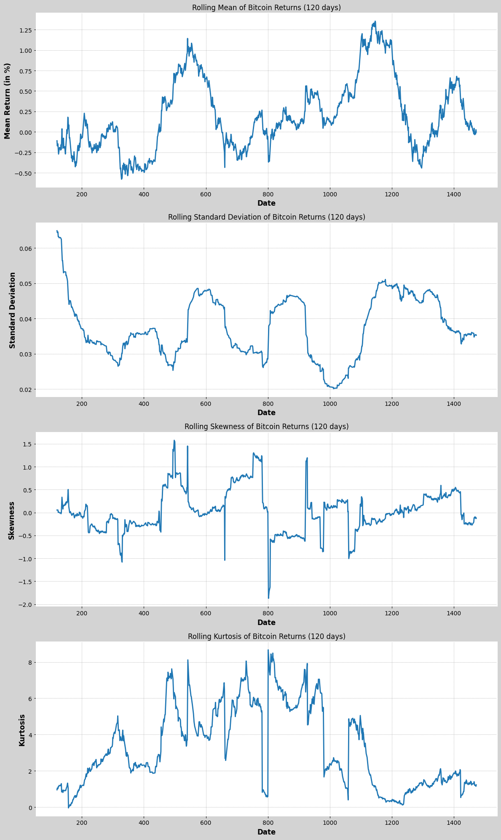
* 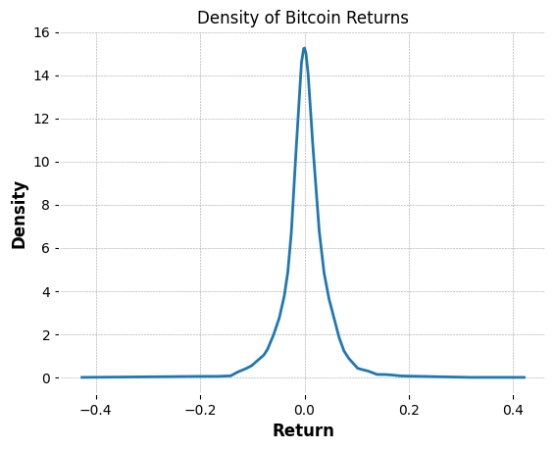
* 

FOMC Meetings

* The Federal Open Market Committee (FOMC) is the branch of the Federal Reserve System (FRS) that determines the direction of monetary policy in the United States by directing open market operations (OMOs).
* It was expected that there would be some major movements across Open,High,Low,Close or Volume across these dates.
* These events happen every 1-2 times every month
* During analysis no major movement was found across these dates, in fact the above features remained mostly constant (indicating the possibility of a sideways market)
* 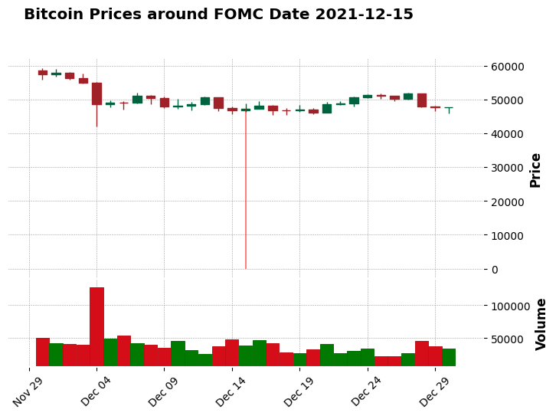
* A sample snapshot

Fourier Analysis

* The Fourier Transform, particularly its computational form, the Fast Fourier Transform (FFT), is a powerful tool in signal processing that decomposes a signal (like a Bitcoin price time series) into its constituent frequencies. This analysis is particularly useful in identifying periodic patterns, cycles, or trends in data.
* Decomposing Time Series into Frequency Components:
  + Bitcoin price data over time is a time series that can be thought of as a signal. FFT transforms this time-based signal into a frequency-based one.
  + It breaks down the entire series into components of different frequencies, allowing us to see if there are any dominant cycles in the data.
* Identifying Dominant Frequencies:
  + FFT analysis reveals the main frequencies (cycles per unit time) present in the Bitcoin data.
  + A high amplitude at a particular frequency indicates a strong presence of that cycle in the price movement. For instance, if there's a significant peak at a frequency corresponding to a 7-day cycle, it suggests a weekly pattern in Bitcoin prices.

Hilbert Transform:

* HT-PERIOD: The period values seem to fluctuate, indicating variable cycle lengths. We don't observe a clear pattern of consistent increase or decrease, which suggests that the market cycles for BTC on the 15-minute chart are not stable but vary over time. This could be indicative of an erratic or complex market behaviour where cycles of different lengths are interacting.
* HT_DCPHASE: During the beginning of a cycle phase (near 0 or 360 degrees in HT_DCPHASE), There is evidence (not very strong, but could worked upon as a strong indicator) of change in direction of trend (uptrend or downtrend)
* At the midpoint of a cycle (around 180 degrees in HT_DCPHASE), one might be cautious of potential pullbacks or reversals.

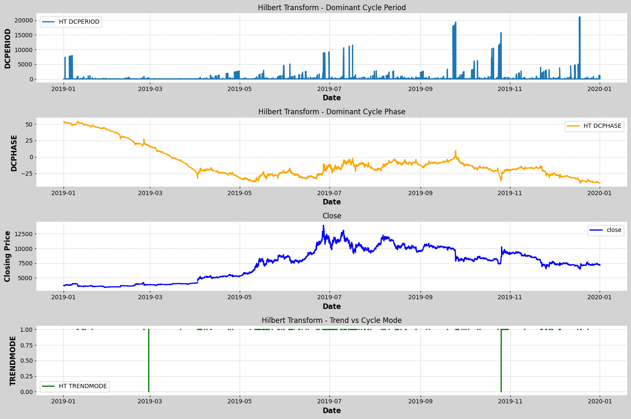

High Volatility

* 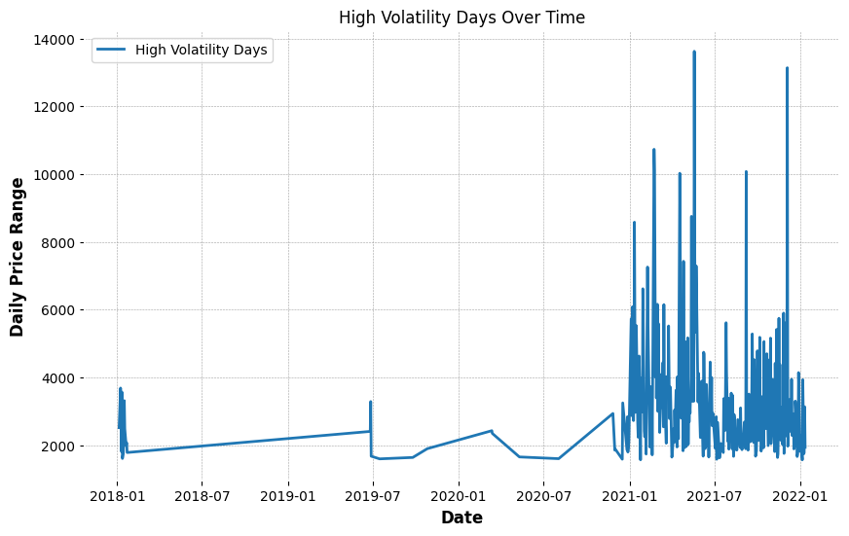
* Till 2018-2021: there were no major volatile days
* After 2021 there was a sudden increase in volatility

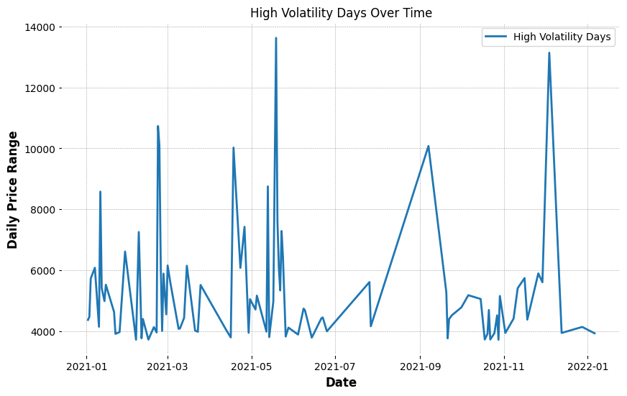

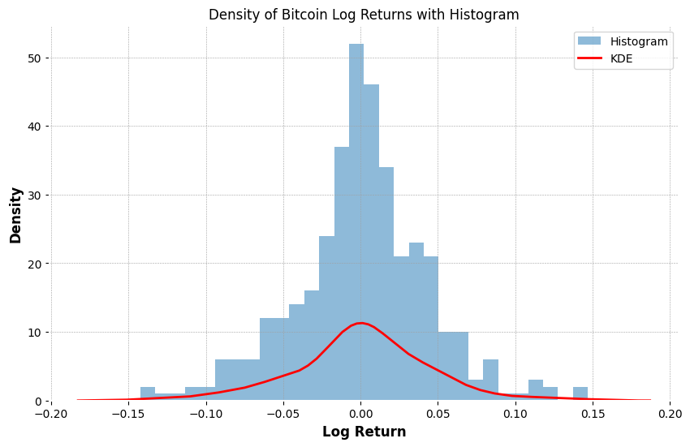

Plot of density of Log returns in 2021-2022